Lab 1:
Iris dataset analysis:
ML algorithm execution platform exploration
All the students should explore these two platforms
- Google Colab
- MiniConda+Jupyter Notebook
Task to be done
- Learn Data Handling Libraries

Tool | Why
NumPy | Arrays
Pandas | Dataset tables
Matplotlib | Graphs

- Learn ML Library: Scikit-learn

3.Analyze Iris Dataset

Task 1: Load the Dataset
from sklearn.datasets import load_iris
import pandas as pd

iris = load_iris()
df = pd.DataFrame(iris.data, columns=iris.feature_names)
df['species'] = iris.target
df.head()

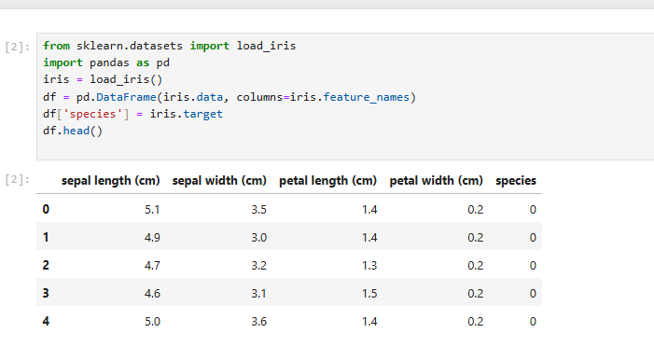

Observation Question: How many columns are there? - 5 + index

Task 2: Understand the Shape
df.shape

Observation Questions
How many rows (examples)? - 150
How many features? 5

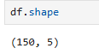

Task 3: Explore Columns
df.columns
df.info()

Which column is the output?
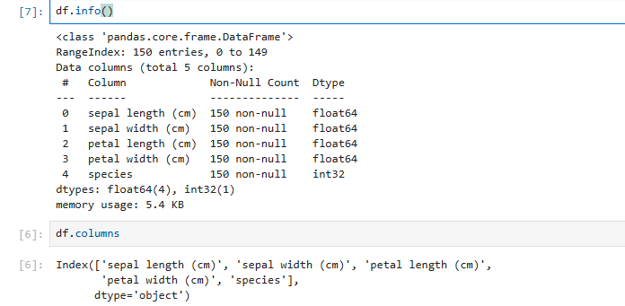

Task 4: Statistical Summary
df.describe()

which feature has largest values? - sepal length (cm)

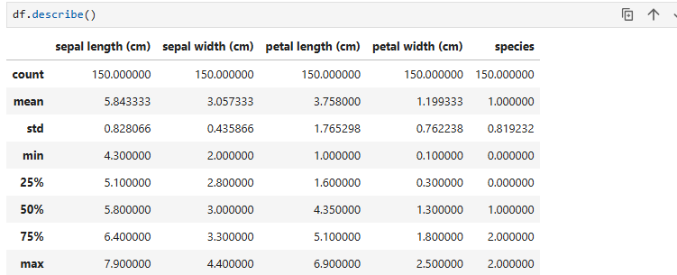

Task 5: Count Each Category
df['species'].value_counts()

Are classes balanced? – yes
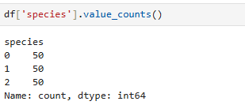
Task 6: Plot One Graph
import matplotlib.pyplot as plt

plt.scatter(df['sepal length (cm)'], df['petal length (cm)'])
plt.xlabel("Sepal Length")
plt.ylabel("Petal Length")
plt.show()

Do you see groups forming? Yes 2

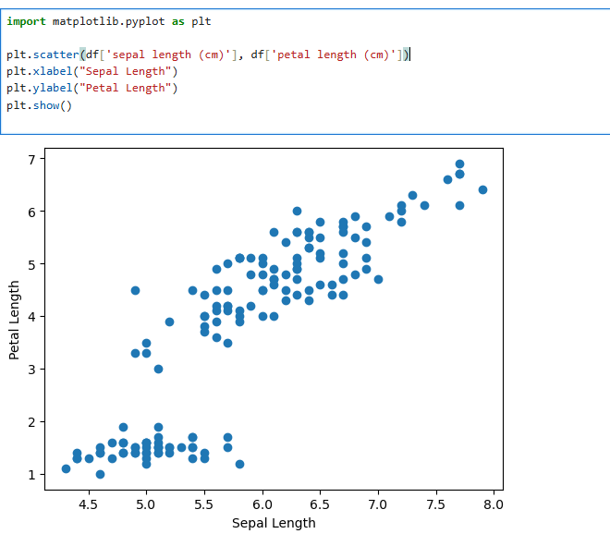

Task 7: Compare Two Species

df[df['species'] == 0].head()
df[df['species'] == 1].head()

Do feature values differ? Yes
Species 0 has smaller petal length and width (1.3-1.5 & 0.2)
Species 1 has larger petal length and width (4-4.9 & 1.3-1.5)

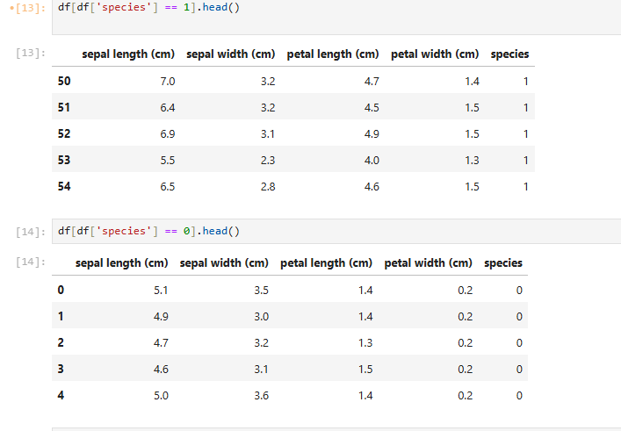

Task 8: Correlation
df.corr()
Q: which features are related
Petal length and petal width are positively correlated
Sepal length is also positively correlated with petal length and petal width

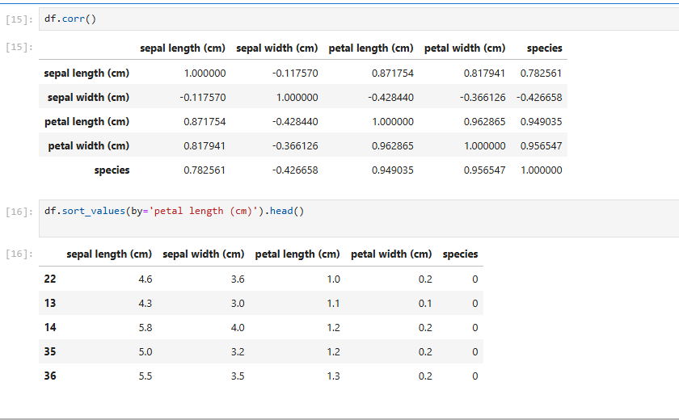

Task 9: Sort data

Q: what happens to species label?
after sorting by petal length , species 0 appears at the top because it has the smallest petal length values.

